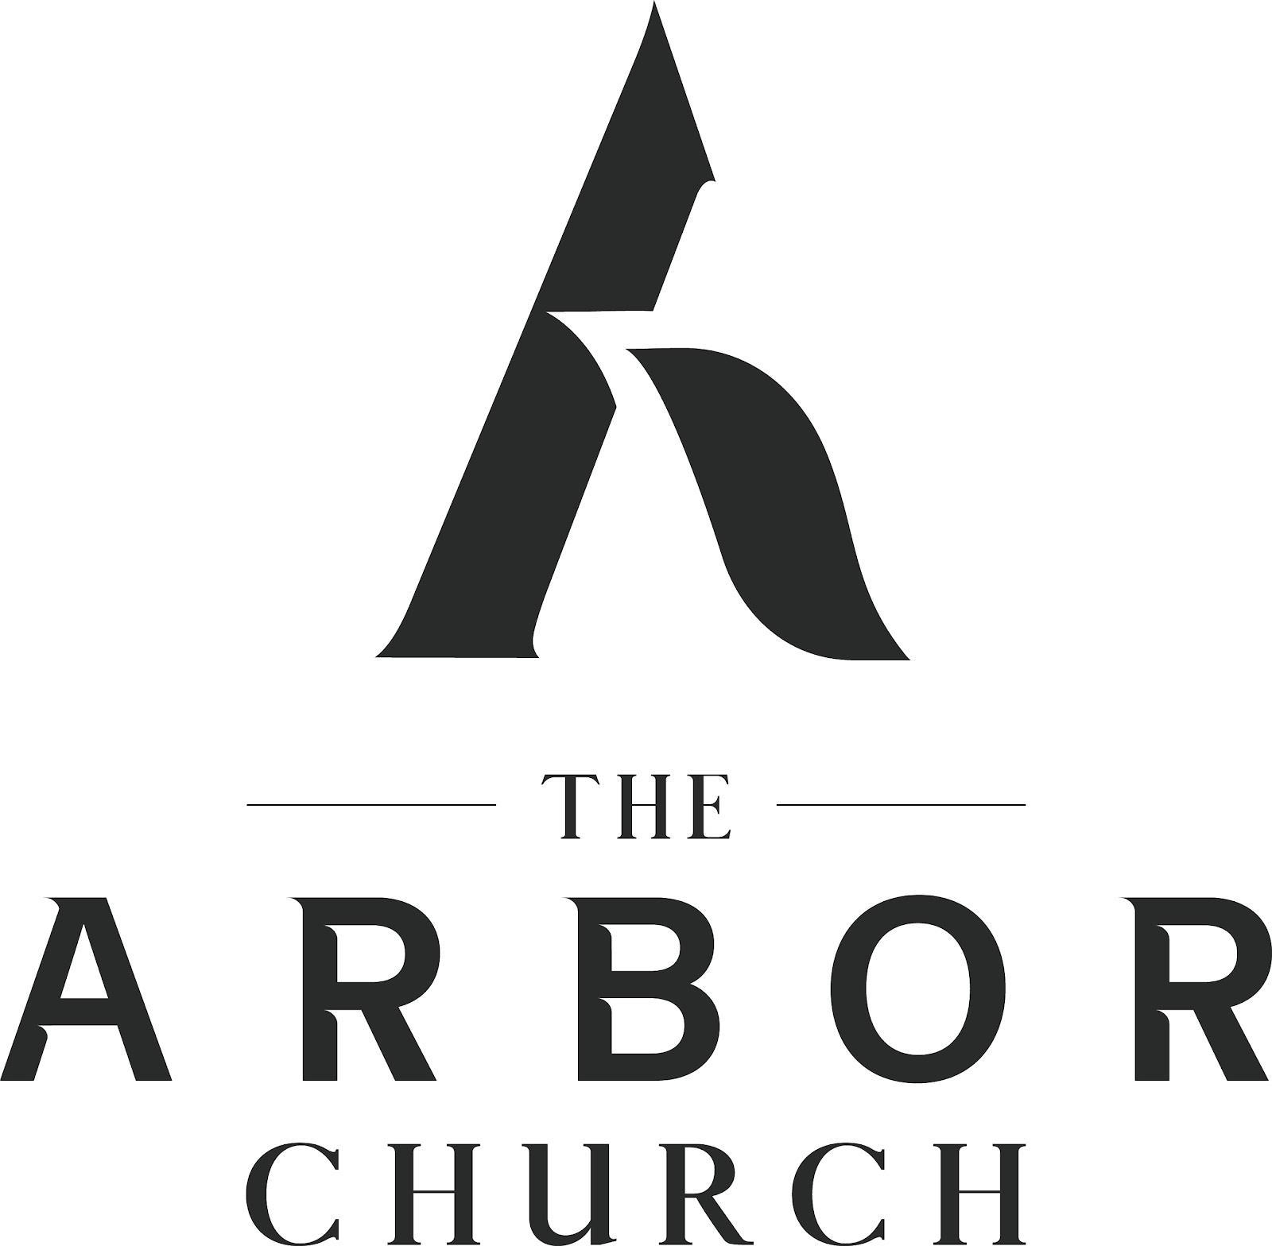
The Arbor Church
Student Ministry Pastor (grades 6-12)
Role Summary
The Student Ministry Pastor provides vision, leadership, and oversight for all aspects of ministry to students in grades 6–12. This role focuses on discipleship, leadership development, volunteer mobilization, and partnership with families to help students become rooted together in Jesus and bring abundant life to their community.
About Our Church
At The Arbor Church we are becoming rooted together in Jesus and bringing abundant life in our community as we embody a culture that is Spirit moved, truth inspired, kingdom minded, joy filled and where everyone is valued. The Arbor Church is in a season of growth and revitalization with currently over 800+ in weekend worship. The Arbor has historic roots in Spring Arbor, Michigan and is next to Spring Arbor University as a strategic ministry partner.

Student Ministry Mission
We aim to fully align the student ministry with the mission of the church. Currently our students grades 6-12 number 150 people in total with around 45 as average on our Sunday night ministry. We seek to help our students become rooted together in Jesus and be a part of bringing abundant life, and this will occur through group life, corporate worship, service, and other rhythms that lead to spiritual growth.

Spiritual Qualifications
- Growing passionate and personal relationship with Jesus Christ
- Agreement with Free Methodist theology and the Arbor Church vision
- Demonstrated calling to student ministry

Leadership Competencies
- Experience leading volunteer teams
- Strong communicator (teaching and relationally)
- Organizational and administrative capability
- Ability to build relationships and disciple students personally

Responsibilities
- Recruit and care for a team of volunteer leaders for student ministry
- Develop and implement a discipleship plan that aligns with The Arbor Church’s growth path
- Oversee communications with students and parents
- Plan Sunday evening programming, retreats, trips and special ministry events
- Provide leader trainings and family resourcing
- Take part in the collaborative work of the leadership team of the church and with other youth ministers
- Compose the annual budget for Student Ministry and monitor it

General Pastoral Expectations
- Live a life of integrity with spiritual and emotional maturity.
- Practice regular spiritual disciplines.
- Prioritize spiritual health, family health, and ministry effectiveness in that order.
- Faithfully support the church’s mission through prayer, generosity and participation.
- Affirm and uphold the beliefs and values of the Free Methodist Church.
- Contribute well to the cultural health of the leadership team and church.

Educational and Professional requirements
- Bachelor's degree preferred.
- Free Methodist ordination path encouraged.
- Experience with and expressed calling into student ministry.

Supervisor
Lead Pastor - John Lane

Supervisory Relationships
- Meet regularly for encouragement and accountability.
- Work together to evaluate our student ministry.
- Oversee assistants or interns

Employment
Full-Time with benefits
Annual Salary (information upon application) - plus benefits consistent with The Arbor Church pastor’s compensation that includes vacation, health insurance, and pension contribution for ordained elders.

Send cover letter and resume to: johnlane@arborchurch.org
Application period: March 1st through April 30th, 2026

